**COMP4423 – Computer Vision**

**Assignment 1**

**Sign Language Recognition**

**[Deadline:** **23:59:00 Wen 15th March 2023]**

**1. Task Description**

Do you remember the challenge task from the sixth tutorial, called Sign Language Recognition? This task is to develop a sign language recognition system for a real-world scenario that includes 24 hand gestures, each representing a distinct letter (excluding cases for J and Z due to gesture motions). You can utilize the Kaggle dataset (https://www.kaggle.com/datasets/datamunge/sign-language-mnist) and the code of the game rock-paper-scissor for reference. While working on this task, you need to consider multiple questions such as collecting datasets, extracting useful features, selecting a suitable classifier, validating the model, deploying and testing the model in a real-world scenario, identifying problems, and finding their solutions. There are no limitations on the algorithm and implementation ideas. And we do not overly concerned with the final accuracy. You need to provide a detailed report of your step-by-step process for completing the sign language recognition in a real-world scenario, including your ideas, algorithm design, problems encountered, corresponding solutions, and any findings during the task.

***Sign Language letters***

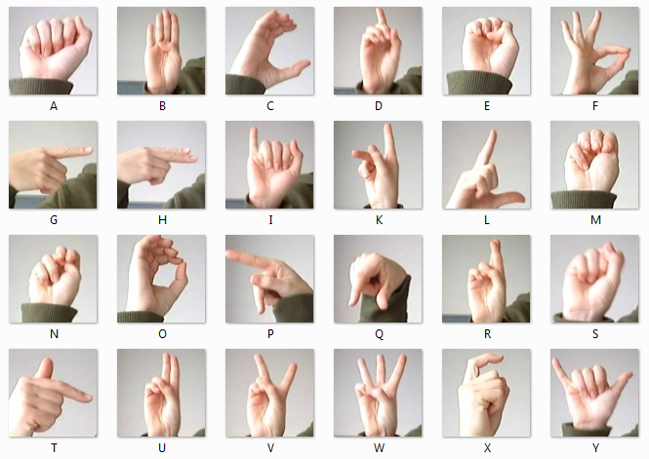

2. Tasks & Assessment

***Please submit a single .py file***

**Task 1** Calling the camera to capture images and ***display them*** successfully. **(5 marks)**

**Task 2 *Collecting the dataset*** and ***extracting the features***. **(15 marks)**

**Task 3 *Training a classifier*** for sign language recognition and ***validating it***. **(20 marks)**

**Task 4** Implementing and testing the trained model in a ***real-world scenario***. **(20 marks)**

**Task 5** A report to show the details of your method. Questions in the template should be answered. **(40 marks)**

**Bonus:** *Submissions with excellent code quality (including comment quality), output accuracy and report quality will be given bonus of no more than 10 marks (the final grade of this assignment will be ).*

3. Submission

Follow the steps below:

1. Name the .py file as Assignment1_<your_ID>_<your_name>.py.  
   *e.g.*, Assignment1_12345678d_CHAN_Dawen.py
2. Name the report as Assignment1_<your_ID>_<your_name>.pdf.

*e.g.*, Assignment1_12345678d_CHAN_Dawen.pdf

1. Compress the two files into a .zip file and rename the .zip file.

*e.g.*, Assignment1_12345678d_CHAN_Dawen.zip

1. Upload the .zip file to the blackboard system.

**Warning:  
If you are unable to complete the whole program, try to accomplish part of the tasks and make sure it can run successfully.**

**Any wrong file naming and submission will be given a ZERO mark in this assignment.**

The deadline for this assignment is **23:59:00 Wen 15th March 2023**.

Late submission penalty

10% is deducted for each day that the work is late. The penalty will be applied up to a maximum number of three days after and including the submission deadline day. After three days the work will be marked at zero.

**This assignment is individual work. All work must be done on your own. Plagiarism is a serious offence. Copying code from web resources is prohibited as well. Any plagiarism case (for both the copier and the copiee) will be given a ZERO mark in this assignment.**